## Contents

**FROM OUR PRESIDENT** 2

**MEMBERSHIP** 6

**OFFICERS OF THE BRANCH** 8

**OUT & ABOUT WITH AAUW** 9

**SAVE THE DATES** 10

**AAUW PROGRAMS** 11

**BOOKS** 12

**LUNCH POLICY** 15

**GUESTS** 18

**OPENING DAY** 19

**GALA 2024** 31

**HOLIDAY LIGHTS** 54

**ROOM RESERVATIONS** 56

**DEVELOPMENT** 58

**THE LIBRARY** 59

**PROFESSIONAL AND CASUAL BUSINESS CLOTHING DRIVE** 61

**MITTEN COLLECTION** 62

**NOMINATING COMMITTEE** 63

**COURTESY REQUESTS** 64

**BAD WEATHER CLOSING** 65

# FROM OUR PRESIDENT

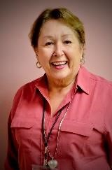BECKY FARBER

As we embark on a new year,

the AAUW community is filled with excitement and renewed freshness. Each fall brings those “returning to the routine” feelings along with a feeling of a new beginning and an opportunity to make everything even better. Our many energetic and hard-working program committees have planned some very exciting and creative programs. The presenters come from a variety of fields, many of which we have not explored before.

The Long-range Planning Committee has been meeting all summer to finalize the details of the long-range plan and identify the very important committees that will be responsible for executing the plan. It proposes an agenda that will help determine the future and support the strategic direction AAUW will take over the next five years.

Our major fundraiser, the Gala, will be held at The Metropolitan in Golden Valley and will introduce many new and exciting features. Mark your calendars for Wednesday, November 6, for a fun-filled evening of entertainment and congeniality. We are grateful to the Gala Committee for its energy, creativity, and thoughtfulness.

Last year the ERA Minnesota did not pass in our legislature to become part of the voting process in 2024. That means the effort to have the ERA amendment become part of our Minnesota Constitution is not yet accomplished. We must continue to inform and lobby our legislators of the need to amend the Minnesota Constitution by “adding a specific guarantee that equity of rights under the law shall not be denied or abridged by state or any of its cities, counties, or other political subdivisions on account of race, color, creed, sex, sexual orientation, gender identity or expression, age, disability, ancestry, or national origin.” I know many of us fought for equal rights for women and girls in the ‘60s and ‘70s and thought we had accomplished our goal. We accomplished many of the goals, but our journey is far from over. We need everyone to support the ERA Minnesota.

Last spring at the annual meeting with my induction as your new president, I asked each of you to contribute one hour per week beyond our Monday meetings to help AAUW achieve its goals. We need everyone to be on board and to help. I realize that health and age may determine how much each of us can do, and I continue to believe that we are all able to expand our volunteerism. Find your way. I paraphrase John F. Kennedy: “Ask not what AAUW can do for you, but what you can do for AAUW.” Every member has a skill/ talent to contribute. We are one of the most accomplished groups in the Twin Cities.

As we eagerly anticipate the start of a new term, let us carry forward the lessons learned, the friendships forged, and the spirit of change. I believe we can work together to build on AAUW’s very strong past. As a matter of fact, I believe that, with your input and commitment, we will continue to thrive.

It is comforting to know that AAUW is continuing to meet our mission of advocacy, research and education for women and girls.

With much gratitude for all your efforts,

Becky Farber, President

Minneapolis Branch AAUW

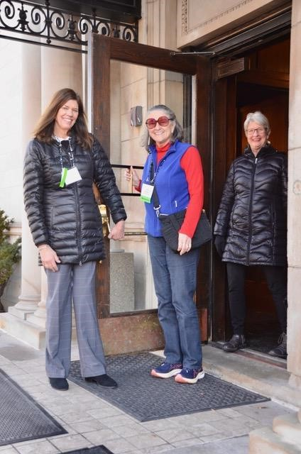

WELCOME TO AAUW

MINNEAPOLIS

# MEMBERSHIP

AAUW members are the most valuable asset of our organization. The most important responsibility of the Membership Committee is to ensure members feel valued and respected. Seeing that smiling face opening the door for you when you enter the Gale is a fitting introduction to the many friends you meet when you go downstairs into the

Presidents’ Hall. Hearing “Glad you made it here today” gives the heart a feeling of belonging. First and foremost, we want our members to feel appreciated and welcomed.

The Membership Committee, with the able partnership of the Marketing Committee, seeks to invite new members into Minneapolis AAUW. At the membership table in the lobby of the Presidents’ Hall, guests are warmly greeted as they sign in and receive information telling them about our organization and why joining Minneapolis AAUW is a terrific decision! We are thankful for the many members who bring guests to our Monday sessions. Those guests form the foundation of our new membership.

Minneapolis AAUW is more than expanding one’s knowledge through expert speakers each Monday. Minneapolis AAUW is more than supporting sixteen college scholarships for Minneapolis Public School female graduates. Minneapolis AAUW is more than organizing its members to become active supporters of causes to help women and families, it also encourages life-long learning, It is also about belonging to and creating friendships with a wonderful group of curious, educated, active women and men.

Membership Co-chairs,

Rae Beth Cornelius and Victor Barela

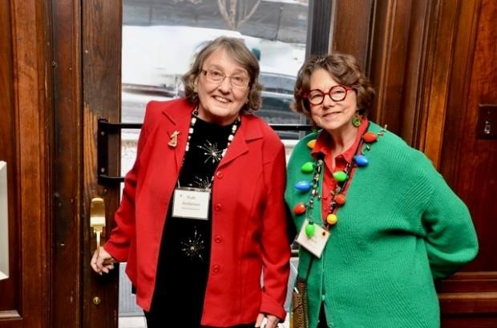

**RUTH RUTHARNDERSEN AND UTH ANDERSENANDERSEN AND N ANCY ANDN SNANCYJOQUIST ANCY SJOQUIST SJOQUIST**

# OFFICERS OF THE BRANCH

**2024-2025**

President Becky Farber

Membership Co-Vice Presidents Victor Barela

Rae Cornelius

Program Development Vice President Jan Mosman

Marketing Vice President Judy Romlin

Development Vice President Nell Wegmann

Treasurer Laura King

Secretary for Recording Ann Roach

Director at Large Ann Vanvick

**PAST PRESIDENTS**

Past Presidents

# OUT & ABOUT WITH AAUW

Our Out & About Committee plans monthly outings for our members. After organizing three fascinating outings this summer: the Mayo Clinic in Rochester; the Swedish Karl Oskar House in Lindstrom with a boat ride at Taylors Falls; and the Eloise Butler Wildflower Garden, we are planning to stay close to home this fall. Bring cash on AAUW’s Opening Day so you can sign up for these fun outings:

1. Padelford Sightseeing River Cruise on Friday, September 27, at noon - $20
2. A private tour of Lakewood Cemetery on Thursday, October 10 at 3:00pm -

$10 We’d love more members on the committee.

Contact Pat Deckas Becerra at 952-9291428 or Susan Tasa at 612-777-8008.

Out and About in Lindstrom, MN

# SAVE THE DATES

September 27, Out and About, Padelford Sightseeing River Cruise

October 7, Professional Clothing Drive

October 10, Out and About, Tour Lakewood Cemetery

November 6, Gala, “Learning is Key” Metropolitan Ballroom

December 16, Holiday Lights

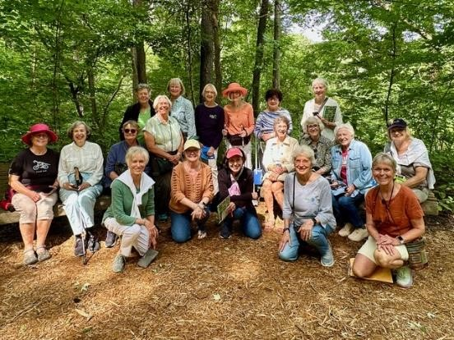

**ELOISE BUTLER WILDFLOWER GARDEN**

# AAUW PROGRAMS

### Topics

* The Arts
* Education
* Empowering Women
* Environment
* Equity, Justice and Inclusion
* Health
* Literary Pursuits
* Public Policy
* Science & Technology

**Focus Days/International Day**

* Nov 18: MN’s Smaller Museums
* March 31: That’s Entertainment
* April 21:International Day

Tibet

**4th Monday Interest Groups**

Fourth Mondays at 9:30 a.m.

Fiction Book Discussions

Nonfiction Book Discussions

Great Decisions

Travel

Hot Topics

Beading

# BOOKS

### 4th Monday Fiction Literature

October  ***Iona Iverson’s Rules for***

***Commuting***

Clare Pooley

November ***Across the Lake***

Patrick Hicks

January ***The River We Remember***

William Kent Krueger

February  ***North Woods***

Daniel Mason

March ***The Women***

Kristin Hannah

April ***Table for Two***

Amor Towles

### 4th Monday Nonfiction Literature

**Nov 25th *In Love: A Memoir of Love and Loss***

#### Amy Bloom

**Feb 24th *Death and Life of the Great***

***Lakes***

#### Dan Egan

**April 28th  *A Fever in the Heartland:***

***The Ku Klux Klan’s Plot to***

***Take Over America, and the***

***Woman Who Stopped Them***

**Timothy Egan**

### Mystery Books

**Sept 25th*****The Man in the Water***

**David Housewright**

Books by authors coming to speak

September 23 – *They Don’t Want Her There*

by Carolyn Chalmers

Equity/Justice/Inclusion

September 30 – *A Council of Dolls* by Mona Sue Powers Literary Pursuits

October 14 – *When Minnehaha Flowed with*

*Whiskey*

By Karen E. Cooper

Literary Pursuits

October 28 –*Somewhere in the Unknown World*  by Kao Kalia Yang

Equity/Justice/ Inclusion

October 28 – *Unsafe at Any Meal*

By Sr. Renee J. Dufault

Health

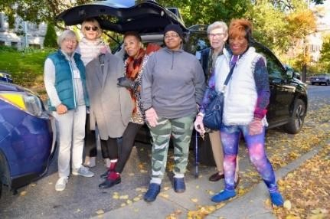

From Me To You clothing collection

# LUNCH POLICY

**RESERVATIONS**

**Lunch reservations MUST be made or cancelled before noon on the Wednesday before the Monday meeting**. **If you do not cancel your reservation, you are expected to pay for that meal, as the branch must pay for the meal**.

1. Online system: <https://signup.com/go/buScVkA> **Be sure to click on SAVE at the end**

**(See more SignUp detail on page 20)**

**OR**

1. Send an email to: **office@aauwmpls.org**

You will receive an email on Tuesday confirming your reservation for the following week.

**CHECK IN AT THE GALE THE DAY OF**

**General Seating and Guests:** There are two clearly marked “Check in and Pay” tables (main floor near elevator and lower level opposite the elevator). Payment is accepted at the check-in tables before 9:30 and 10:45 sessions. **If you arrive later than 10:45 a.m.,** please check in at the second-floor office.

**President’s Table:** Check in on the main floor.

**Same-Day Registration**: To make a same-day reservation, put your name on the list at the main floor check-in table as soon as you arrive at the Gale. **There will be an extremely limited number of same-day reservations.**

**PAYMENT**

**Cash** and checks are accepted at the check-in tables.

**Credit cards** are accepted in the second-floor office. Then bring CC receipt to either cashier.

At the time of payment, you will receive a wrist band which will signify to the servers that you have paid for lunch.

**PRICING**

• All Monday lunches: $25

**SPECIAL DIET MEALS**

Please request a form for special diet meals from

Office Manager Sharon Rauenhorst at 612-8701661. On the day of the meal, pick up your special diet card at the check-in table on the lower floor. Display this card at your table and alert the server to your meal request. If you have made a reservation for a special meal, that will be your meal. Please do not switch meals.

**INSTRUCTIONS FOR ON-LINE**

**LUNCH RESERVATIONS**

1. Click on **Lunch Reservations** in the weekly branch newsletter.
2. Find the **date** you would like to attend and click the **green sign-up button**.
3. Enter your **email address** (your reminders will come to that email). Click **Continue.**
4. Check that the email address you entered is correct. **If wrong:** Click **Back**. **If correct:** Click **Confirm.**
5. Reserve for yourself: put **1** in **“# of Spots” box.**
6. To add a guest. Click **Save and Add Another Person.** Put **1** in **“# of Spots”** box and fill in the guest’s name and information. (You can use your own phone number and email.) Repeat for additional guests.
7. When you are done reserving, click **Save And Done**
8. If you see a series of ads, click on the X in upper right corner to close.
9. The list of dates will reappear. Repeat steps 5-7 for additional dates you want to reserve.
10. **When you are done**, **click on the blue**

**“SAVE” button at the very top of the form.**

1. You will see a list of your reservation dates with the option to print and/or add to your calendar.
2. Cancellation: cancel in SignUp or contact the office office@aauwmpls.org or (612) 870-1661 (by noon Wednesday).
3. You will get a reminder email on Tuesday prior to your reservation date.
4. If you do not get the emailed reminder: A. Check in your spam/trash folder. B. Go to SignUp and sign up if you are not on the list. C. If you are on the SignUp list, please check with the office – Sharon will help you.
5. **If you do not cancel by the prior Wednesday, you are responsible for paying for the meal.**

# GUESTS

Prospective members and guests may attend up to three meetings each program year. Prospective members and guests must register at the Membership Table in the lower level. Guests will receive name tags and be recognized during the meeting.

**Table Reservations**: To reserve a lunch table with your guest, reservations must be made in person on Monday morning at the Arrangements Table on the first floor.

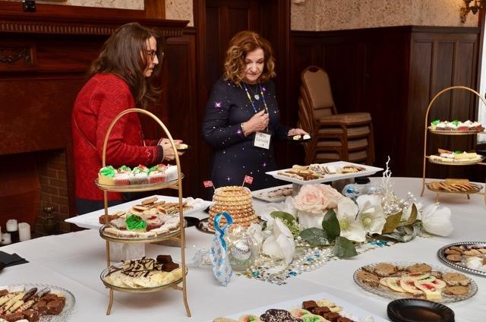

**HOLIDAY LIGHTS**

# OPENING DAY

#### September 16, 2024

8:45 – 9:30 Dining Room

##### Welcome Back Coffee and Teatime

Welcome back to a new and exciting year. Note the earlier start time so you can meet and greet old and new friends and enjoy cookies and beverages hosted by our dedicated Coffee Committee.

9:30 – 10:30

**Welcome & Preview of the 2024-25 Year**

President Becky Farber will welcome us to another exciting and enriching year. Program Vice President Jan Mosman will introduce the Topic, Focus Day and International Day chairs who will give you a preview of the exciting year to come. We will update you on Fourth Monday Interest Group programs and have reports from our Membership and Gala chairs.

Presenter: Jan Heinig Mosman

10:45 – 11:45

##### Meet the YWCA Minneapolis

**Shelley Carthen Watson**, President and

CEO, YWCA Minneapolis

The mission of the YWCA Minneapolis is to eliminate racism, empower women and girls, and promote peace, justice, freedom, and dignity for all. Carthen will talk about how the YWCA Minneapolis, like us, works for the betterment of women and girls. Because our missions align, could there be a relationship between our two organizations as we move forward? Presenter: Nancy Sjoquist

11:45**Recognition of Past Presidents**

Announcements

Luncheon

1:15 – 2:15

**Water in Minnesota and the Supreme Court**

**Jeff Forester,** Executive Director, MN

Lakes & Rivers Advocates (MLR)

The Chevron Decision by the Supreme

Court incentivizes a broad civic base across Minnesota to protect water, air and other natural resources. Rules developed by EPA (including Environmental Impact Statements) could be in question. The Supreme Court does not decide state law, thus the need to ensconce rules in state statutes. Organizing water advocates is essential.

Presenter: Jan Mosman



#### September 23, 2024

9:30 – 10:30Equity/Justice/Inclusion

##### *They Don’t Want Her There*

**Carolyn Chalmers,** Lawyer and Author**Jean Y. Jew**, MD, Prof. University of Iowa College of Medicine.

**Barbara Y. Welke**, Prof. of History and Law, University of Minnesota.

Decades before the #MeToo movement, Dr. Jew brought a sexual harassment lawsuit against the University of Iowa. Chalmers was her lawyer. In the face of the university’s indifference, these two pursued a landmark civil-rights battle. The combination of sex, race and ethnic discrimination and the extraordinary relationship of lawyer and client through adversity makes this panel discussion deeply compelling.

Presenter: Chris Stromgren

10:45 – 11:45 Environment

**What Nature in Our Backyards Can Tell**

##### Us About Climate Change

**Dr. Stephan Carlson,** Retired Professor from the U of MN Extension’s Natural Resources

Phenology is the science of observing the seasonal changes of plants and animals, which humans have done for hundreds of years. Recording nature observations and using apps such as I-Naturalist are chances for people to contribute to ongoing science and show long-term changes in our climate. This session encourages participants to record nature observations in their backyards to understand climate change.

Presenter: Veronica Johnson

11:45Announcements

Luncheon

1:15 – 2:15 Education

##### Ormsby School in Sierra Leone

**Ann Carlson, Pat Deckas Becerra,** AAUW

Members, Minneapolis Branch

Last March, Ann Carlson led a group of four women, Pat Deckas Becerra, Joan Jemison, and JoAnn Knutson, to the very remote African village of Baiwalla, where there is no electricity, running water or paved roads. Their purpose was to set up the first lending library in the region and introduce child- focused learning activities. Ann and Pat will share photos and stories of their work with the teachers at Ormsby School.

Presenter: Kay Kessel

**“*It is Never Too Late To***

***Be What You Might Have***



***Been.”*** George Eliot

##### September 30, 2024

10:30Literary Pursuits

**Genesis of the Novel: *A Council of Dolls***

**Mona Susan Power,** Author

Power will discuss the genesis of her most recent novel, *A Council of Dolls*, a multigenerational story inspired by the experiences of her Yanktonai Dakota ancestors. She may share how writing this book helped in her life’s healing process. Presenter: Barb Link

10:45 – 11:45 The Arts

###### The Art of Conversation and Politics

**Mary Lahammer,** Anchor, Reporter, Producer, Twin Cities PBS

**Please view the documentary before the presentation:** [https://www.tpt.org/jesseventura-shocks-world/](https://www.tpt.org/jesse-ventura-shocks-world/)

Twin Cities PBS anchor/reporter Mary Lahammer will talk about the art of conversation and politics in a divided state that has an independent streak, including her recent documentary on former Governor Jesse Ventura.

Presenter: Shari Parsons

11:45Announcements

Luncheon

1:15 – 2:15Science and Technology

###### How Do I Know? Recognizing and Reacting to Misinformation on Social Media

**Dr. Emily Vraga,** Don and Carole Larson

Professor of Health Communication,

University of Minnesota

Social media offer many benefits to their audiences, but also contribute to the spread of misinformation. Audiences can improve their resistance to misinformation by learning to recognize commonly used strategies and build new literacy habits online. Encouraging people to react appropriately to misinformation can improve the online information environment for everyone.

Presenter: Leslie Swenson

**October 7, 2024**

10:30Long Range Planning

###### Long Range Planning Program

Speaker, Sheila Lind and Jennifer Johnson

It is time to endorse our strategic planning goals by voting at this presentation. You will have a chance to hear about our branch’s past projects and the criteria for future projects requiring funding. We are ready to make some of the goals a reality and we welcome your support and approval!

10:45 – 11:45 Public Policy

###### Union Resurgence

**Bethany Winkels,** Executive Director,

AFL-CIO

Unions are having greater support than they have had in decades. In 2023, Minnesota legislators generated significant pro-worker bills. How does the Labor Federation affect public policy? More workers are showing up at picket lines. What are unions offering members that is creating the union resurgence? Do unions represent men and women equally?

Presenter: Veronica Johnson

11:45Announcements Luncheon

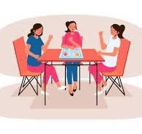

1:15 – 2:15 No scheduled programs.

Check the newsletter for other  activities.

##### October 14, 2024

10:30Literary Pursuits

***When Minnehaha Flowed with Whiskey:***

###### *A Spirited History of the Falls*

**Karen E. Cooper**, Photo Historian,

Researcher/Writer

Cooper will speak about her Minnehaha Falls book, illustrated with her slide show of vintage pictures of the era. Her story is a rollicking tale laced with whiskey, greed, corruption and arson. This is a fascinating history of the famous Minnehaha Falls and early Minneapolis. Presenter: Gini Hickman

10:45 – 11:45 Education

###### Creating Access for Women in Technology and Trade Careers

**Ashley Van Lieshout,** Program Director,

Women in Technical Careers (WITC),

Dunwoody College of Technology

Dunwoody recognizes the importance of creating access for women to pursue degrees in fields that are traditionally male dominated: primarily technical and trade careers. This awareness drives the mission of Dunwoody WITC, which is to reduce the unique barriers that women face when going to college through financial assistance, community and job offers.

Presenter: Lois Petersen

11:45Announcements

Luncheon

1:15 – 2:15 Empowering Women

###### Storming the Gates: Breaking Down Barriers at the U.S. State Department

**Cynthia Saboe,** Former Executive Director,

Bureau of Overseas Building Operations,

U.S. Dept. of State

During 40 years at the State Department, Saboe helped organize numerous networks, including Executive Women at State, a group supporting and mentoring career women. Saboe describes the evolution of the group into a 1,500-member network supporting women from their entries at the State through their appointments to senior leadership positions. Presenter: Kay Bochert

# GALA 2024

Let’s Meet at the Met!

**The Metropolitan**

Located near Hwys 394 and 100

## **November 6, 2024 5pm to 9pm**

*Learning is Key!*

*Games, Photos, and Fun

*Entertainment you will love!

*Program

*Plated Dinner *Cash Bar

*Fun, Fun, Fun

Don’t *forget to buy your ticket*

### October 21, 2024

9:30 - 10:30 Science and Technology

#### Our Scholar’s Role in the U of MN Solar Vehicle Project

**Lily Andersen,** U of MNStudent and current AAUW Scholar

Andersen, one of our AAUW scholars, is the electrical lead on the latest University of Minnesota’s Solar Vehicle Project and went with the team to competition in Australia. She will present an overview of the Solar Vehicle Project, including the design process, racing stories, and regulations these cars must meet for energy optimization.

Presenter: Carol Sheldon

10:45 – 11:45 Environment

#### East Phillips Neighborhood Institute (EPNI)

**Dean Davolis**, CEO, DJR Architecture,

Chair and Executive Director, EPNI

EPNI is a community-led, grassroots nonprofit dedicated to advocating for environmental justice and people’s participation within East Phillips and the broader Minneapolis community. Their overriding goal is to prevent more pollution from damaging the already healthchallenged, low-income, and BIPOC community while promoting healthy, sustainable futures. They are fighting to save the 28th St. Roof Depot Building and transform it into a community-led Urban Farm.

Presenter: Rae Cornelius

11:45 Announcements

Luncheon

1:15 – 2:15 Public Policy

#### Moving People Out of Poverty, One Car at a Time

**Cathy Heying,** Executive Director, The Lift

Garage

The relationship between access to transportation and stable employment, education, and housing is fundamental. The importance of accessing affordable car repair to achieving success often goes unrecognized. It needs to be considered a key component of public policy and community planning. The value of passionate, purposeful individual action cannot be underestimated in improving people’s lives. Presenter: Glenna Case

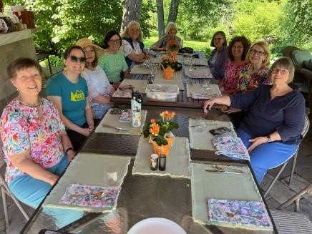

**SCIENCE AND TECH COMMITTEE SUMMER**

**GET-TOGETHER**

Community is built by joining a committee.

October 28, 2024

9:30 – 10:30 **Fourth Monday Interest**

**Groups**

Please see the Bulletin page 11.

**Travel**  Presidents’ Hall

**Africa – Snakes, Cheetahs and Me from**

**Land, Air and Sea**

Leader: Rita Britton

Join Rita on a cruise around South Africa visiting historical sites and exploring the dunes of Namibia. The ride on the dunes is spectacular. From there we go on safari in Botswana and Zimbabwe, both with gorgeous landscapes and animals. You will really want to hear the safari stories.

**Fiction Book Discussion**  Heritage Room ***Iona Iverson’s Rules for Commuting*** by Clare Pooley

Discussion Leader: Lynn Hjelmeland

Every day Iona and her dog ride a train to work. She sees the same people but they never speak until one day an emergency brings them all together. Talking to strangers can teach you about yourself and the world. This book is sunny, funny and full of heart.

**Beading** Dining Room

Leader: Ann Vanvick

Ann will assist you in making a one-of-akind beaded name tag (or glasses/mask holder) for yourself at the low price of $5. Or you can make one to be sold to raise funds for our branch.

**Hot Topics**  Founders Room

Leader: Lil Lindsey

Join us for a lively interactive discussion on newsworthy events and more.

10:45 – 11:45 Equity/Justice/Inclusion

##### *Somewhere in the Unknown World*

**Kao Kalia Yang**,Author

There are refugees all over our country. But beyond the headlines, few know who they are, how they live, or what they have lost. Yang, a Hmong refugee and award-winning author, has gathered stories of the stateless who today call the Twin Cities home. *Somewhere in the Unknown World* is her collective refugee memoir.

Presenter: Lil Lindsey

11:45Announcements

Luncheon

1:15 – 2:15 Health

##### *Unsafe at Any Meal*

**Dr. Renee J. Dufault,** retired Public Health

Service officer

Each year, Americans consume hundreds of FDA-approved food products that contain dangerous compounds. Dufault, Co-founder and Executive Director of the non-profit Food Ingredient and Health Research

Institute, will take us on an investigative journey to uncover how these substances get in our food and what the latest research reveals.

Presenter: Lil Lindsey

### November 4, 2024

9:30 – 10:30 Health

#### Navigating Polypharmacy

**Patty Doyle,** Dr. of Pharmacy and Board- Certified Geriatric Pharmacist

Doyle will discuss strategies to navigate the multiple medications prescribed for chronic diseases, acute illnesses and other “asneeded” conditions. She will review drugdrug and drug-disease interactions, the prescribing cascade, and drug optimization. Gain practical information and tips to understand your own medications and their impact on your health. Presenter: Karen Ringsrud

10:45 – 11:45 Public Policy

**Minneapolis Government Restructure: Success, Failure, or Something in Between?**

**Lisa Goodman**, Retired Member of the

Minneapolis City Council

Minneapolis’ Weak Mayor/Strong City Council Charter existed for 100 years. In 2021, citizens voted overwhelmingly to restructure city government by creating an Executive Mayor/Legislative City Council Charter, similar to cities throughout the country, including other Minnesota cities. Did this Charter change produce expected results? What new challenges emerged? What has been the reaction to this dramatic change in governance? Presenter: Karen Ringsrud

11:45Announcements

Luncheon

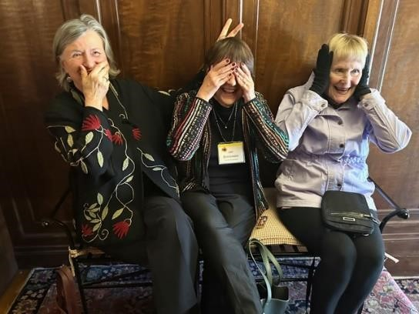

Pat Ciardelli, Jan Bobrowske, Betsy Parks

1:15 – 2:15 No scheduled programs.

Check the newsletter for other  activities.

### November 11, 2024

9:30 – 10:30 The Arts

#### Finnish Art of Himmeli

**Tia Keobounpheng**, Artist

Keobounpheng is a multi-disciplinary artist who has studied the Finnish art of Himmeli, creating complex, graceful straw mobiles. As a descendant of Finnish and Sámi people, she uses generational patterns that have kept her from seeing the 'un-see-able.' She uses geometry to move her consciousness beyond binary narratives, in order to imagine a more complex framework of understanding. Her studio is in Northeast Minneapolis. Presenter: Judy Anderson

10:45 – 11:45 Empowering Women

**What Still Needs to Happen...**

**Tovah Penning,** Installer at [Standard Heating & Air Conditioning](https://www.facebook.com/StandardHeating)

…..to make working in the field good for women? Tovah Penning will share her story about the challenges she faces working in a non-traditional job. She attended Dunwoody College and benefited from the Women in Technology Careers group while she learned a trade. While that helped get her started, she sees the struggles women continue to face on and off the job. Presenter: Nell Wegmann

11:45Announcements Luncheon

1:15 – 2:15 Education

**Rethinking Education in the Age of AI**

**Mozhdeh Khodarahmi,** Associate Library

Director for Access, Instruction and

Research Services, Macalester College

Artificial intelligence is reshaping education, from teaching methods to learning outcomes and evaluations. Khodarahmi will discuss how to responsibly ensure the benefits of AI, while mitigating potential risks. She is integrating Artificial Intelligence into the curriculum and enhancing competency of the community at Macalester College.

Presenter: Carole Clemens

### November 18, 2024 Focus Day

#### Minnesota’s Smaller Museums

9:30 – 10:30

**Many Voices, Many Stories, One Place:**

##### Historic Fort Snelling

**Speakers:** Interpreters from Fort Snelling

The confluence of the Mississippi and Minnesota Rivers is the historic homeland of the Dakota people, *Bdote*. Collaborations with groups representing centuries of history has resulted in a new interpretive program at this historic fort. Fur traders, soldiers, imprisoned Native people, and African Americans fighting for their freedom have also left their voices at this sacred site. Their stories are riveting!

Presenter: Kate Johnson

10:45 – 11:45

##### The Schubert Club’s Music Museum

**Kate Cooper**, Museum Director and

Director of Education

Cooper will present a history of the Schubert Club, one of the five oldest musical arts organizations in the country. The Schubert Club brings acclaimed musical artists to its recital series and offers immersive, hands-on educational programs. Its collection of keyboard instruments from around the world, composer letters, and manuscripts are in beautiful galleries on the second floor of the Landmark Center. Presenter: Kate Johnson

11:45Announcements

Luncheon

1:15 – 2:15

**Hennepin History Museum:**

##### Just Across from Fair Oaks Park

**Speaker,** Museum Staff

Founded 86 years ago with a WPA grant to collect the history of this area, the Hennepin History Museum has collections that date from Minnesota’s pioneer days through the 1970s. Ball gowns, wicker baby carriages, dolls, memorabilia from stores and restaurants, photograph collections, and an outstanding research archive are just some of its riches. The Museum also has plans to create spaces where our communities’ stories can be told. Presenter: Kate Johnson



### November 25, 2024

9:30 to 10:30 Monday Interest Groups Please see the Bulletin page 11.

**Nonfiction Book Discussion**  Founders

Room

***In Love: A Memoir of Love and Loss***

[Amy Bloom](https://www.amazon.com/Amy-Bloom/e/B000APP47O/ref=dp_byline_cont_book_1)

Discussion Leader: DeDe Scanlon

Their world was altered forever when an MRI confirmed what they could no longer ignore: Brian had Alzheimer’s disease. Bloom sheds light on a part of life we so often shy away from: its ending. *In Love* is an unforgettable portrait of a beautiful marriage, and a boundary-defying love.

**Fiction Book Discussion** Heritage Room

***Across the Lake*** by Patrick Hicks

Discussion Leader: Jan Brue Enright

Set in Nazi Germany’s only all-female concentration camp, *Across the Lake* is a story of survival amid overwhelming brutality. The book portrays how the female prisoners supported each other while holding onto their humanity. This is also a story about the female guards who were every bit as vicious as the SS. Participating in this discussion will prepare members for Dr. Hicks' presentation on January 27, 2025.

**Hot Topics**  Founders Room

Leader: Lil Lindsey

Join us for a lively interactive discussion on newsworthy events and more

**Great Decisions** Presidents’

Hall

**Technology Denial and Sino-American**

#### Rivalry

Leaders: Ruth Andersen, Sharon Eian

The US and China are rivals with the relationship marked by numerous conflicts on Taiwan, the South China Sea, Hong Kong, Chinese support for Russia and North Korea, and a turn towards channeling economic power into military power. Is this a new cold war? A new technology war? We will also briefly review the history of US – China relations.

10:45 – 11:45Development Committee

#### Gratitude

**Jennifer Olson and Nell Wegmann**,

AAUW members

The Development Committee would like to celebrate our members’ generosity. Stories will be shared, many not previously told, of financial gifts intended to promote equity for women and girls, locally and nationally. We plan to acknowledge the gifts of thousands of hours volunteering on committees, recruiting speakers, participating in outreach, and supporting the Branch in other ways. We will have facts, figures and fun.

Presenter: Nell Wegmann

11:45Announcements

Luncheon

1:15 – 2:15 Empowering Women

#### Empowering Women In the Most Basic, Personal Way

**Ruth Richardson,** President and CEO,

Planned Parenthood, North Central States

Richardson has hit the ground running in her role at Planned Parenthood. She began working for women’s rights as a MN State Representative, championing many bills that became law. She continues on a path to empower women seeking reproductive healthcare. Her life story is a compelling one in her rise to these high-level positions.

Presenter: Sue Kearns

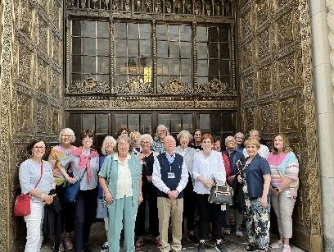

**1OUT AND ABOUT AT THE MAYO CLINIC JUNE 2024**

### December 2, 2024

9:30 – 10:30 The Arts

#### The Artistic Riches of Romagna

**Anna Bonavita**, Founder/Executive

Director at Esperienza

From ancient to modern, a wealth of artistic treasures is hidden in my favorite region of Italy. Immerse yourself in the universe capital of ceramics. Discover the ancient textile printing art that’s still prized by many and practiced by local artisans. Dip your toes into the glittering mosaics of Ravenna, steeped in history and fascinating stories.

Presenter: Pamela Diamond

10:45 – 11:45 Science and Technology

**How Can We Avoid Scams and Fraud?**

**Marty Fleischhacker,** Senior Financial

Fraud Ombudsman, MN Department of

Commerce, Civil Enforcement Liaison

Fraud can happen to anyone. Scammers are very accomplished at their work, and even very smart people have been scammed.

Fleischhacker has years of experience in this department. He will review ways to identify a possible scam and avoid it. We owe it to ourselves to be informed to fight this multibillion-dollar industry. Presenter: Nan Beman

11:45Announcements Luncheon

1:15 – 2:15 No scheduled programs.

Check the newsletter for other  activities.

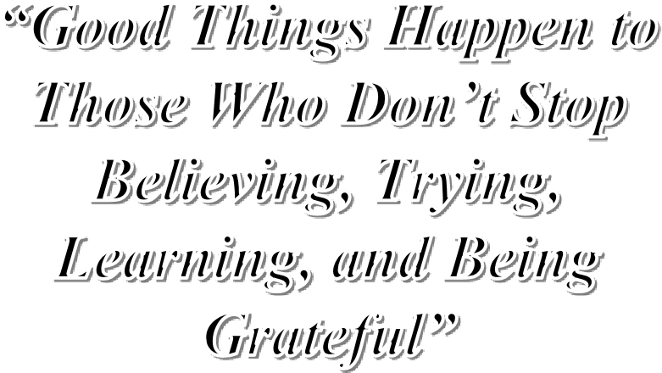***Those Who Don’t Stop Believing, Trying,***

***Learning, and Being***

Roy T. Bennett

**Holiday Lights 2024**

**December 16, 2024**

*Fun For All*

**Social Hour**

**Music with James Rocco**

**Special Luncheon**

**Books for the Holidays with**

**Sue Zumberge, Owner, SubText Books**

**– Don't forget to buy your lunch ticket**

**Regular lunch reservations will NOT apply. Open seating at tables.**

### December 9, 2024

9:30 – 10:30 Education

#### All Things All Square

**Emily Hunt Turner,** Founder and CEO,

The Legal Revolution

All Square, a nonprofit social enterprise, is changing the way criminal records are used across Minnesota. Using their grilled cheese restaurant and civil rights law firm, this organization has a blueprint for reaching catalytic change not just locally but nationally. Hunt Turner will showcase All Square's programs, social impact, and motivation to heal the harms done by mass incarceration. Presenter: Kay Kessel

10:45 – 11:45 Equity/Justice/Inclusion

#### Exploring the History of White Nationalism

**Brandon Schorsch**, Combating Hate,

Jewish Community Action

Schorsch returns to help us explore the history of white nationalism and American fascism as we look at the rapidly changing world of online cultures. He will also examine how the struggle against antisemitism is interlinked with the struggles against other marginalizations and oppressions including racism, misogyny, queerphobia and classism.

Presenter: Janet Triplett

11:45Announcements Luncheon

1:15 – 2:15 The Arts

#### Resurgence of Craft

**Greg Wright**, Executive Director, North

House Folk School, Grand Marais, MN

North House Folk School in Grand Marais is about enriching lives and building community through craft. Craft, creating things of beauty with utility, connects people with people but also bridges the past, present and future. Classes from one day to two weeks are offered throughout the year, ranging from fiber arts, to blacksmithing, to baking bread, to building a timber-framed cabin.

Presenter: Jennifer Olson

**December 16, 2024**

# HOLIDAY LIGHTS

9:30 – 10:30Join us for coffee, tea, and cookies and visit with old & new friends and members.

10:45 – 11:45 Program President’s Hall

**James Rocco**, vocal entertainer.

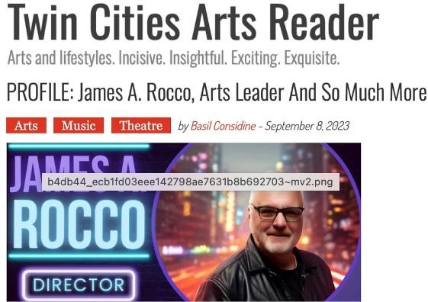

Rocco has a rich history of singing from an early age, performing in NYC as a child actor, serving as Artistic Director of the Ordway for 12 years, producing and directing on Broadway, and regularly performing now at Crooners! We can all sit and enjoy a wonderful hour of music!

11:45Announcements

12:00 Luncheon: Enjoy a special lunch on

this special day

1:15 – 2:15

**Sue Zumberge,** Owner, SubText Books

The afternoon program will again be with our friend, Sue Zumberge from SubText Books in St. Paul, who will present a book list and store information for our members.

Patricia Day & Lynn Hjelmeland

Holiday Lights Co-chairs

# ROOM RESERVATIONS

First Monday Afternoon Activities

Beginning this program year, there will be no 1:15 PM programs on the first Monday of each month. Instead, much of the Gale Mansion will be available for committee meetings and social activities.

All members are welcome to sit in on committee meetings and learn about the wide variety of activities going on in our branch. The social activities will be an opportunity to play a game, learn a skill, have an interesting discussion, make new friends and more.

We tentatively have the following rooms available: Presidents’ Hall, the Founders Room (the smaller dining room), the

Minneapolis Room and Fellowship Room (both on the Second Floor). Some of the larger rooms may be shared spaces with more than one activity.

If you would like to reserve a space for a meeting or social event, please contact Kerry Noyes, Meeting Scheduler, at kerrynoyes@gmail.com. Please describe the activity you would like to sponsor and how many people you expect to attend.

If you have reserved a space for an activity and want to encourage participation, please contact Office Manager Sharon Rauenhorst to put an announcement in our weekly

email. Sharon’s address is office@aauwmpls.com.

The first Mondays are Oct 7, Nov. 4. Dec. 2, Jan. 6, Feb. 3, Mar. 3, April 7 and May 5.

*If the plan doesn’t work, change the plan but not the mission.*

# DEVELOPMENT

ADVANCE OUR MISSION WITH AAUW

MINNEAPOLIS GIFT PROGRAMS

Legacy, or planned giving, is a way for you to help ensure that the AAUW mission of working for equity for women and girls, and our branch, lives on after you are gone. Please consider designating AAUW Minneapolis Branch in your will or other planned giving. There are many ways to do this now and for the future, including wills, trusts, Donor

Advised Funds, Required Minimum

Distributions, Qualified Charitable

Distributions or as a beneficiary of an IRA or insurance policy.

Consult your attorney or financial planner for additional information. Since AAUW Minneapolis is a 501(c)(3) organization, giving to our branch is tax deductible. Contact

Nell Wegmann (612-323-8288) of the Development Committee if you have questions.

Nell Wegmann, Development VP

# THE LIBRARY

Come On Up and See Us

Want to check out the latest best seller? Need a new mystery to read? How about a jigsaw puzzle to stimulate your brain? They are all here in your AAUW library. Our new location in the Association Room is on the second floor across the hall from the office and the elevator. Come up and visit us; we would be delighted to see you.

Our staff tries to supply you with the latest books: fiction, mysteries, memoirs, nonfiction, and when available, science fiction. We also try to provide a diverse collection that reflects many cultures.

There are no fines for overdue books. We are just grateful when the books are returned (two weeks, please). These are your books, and we want you to enjoy them.

We continue to sell used books – hardcovers for $1 and paperbacks for $0.50. Proceeds from the used books allow us to buy more books for the collection. Please bring us your used books, preferably not more than five years old. And don’t forget to bring us your puzzles.

You are always welcome in the library. Come in and see what books we have – our selection of bestsellers may surprise you. We would like to think we can provide you with your reading needs. We look forward to seeing you.

Judy Vermeland-Wendt, Chair, Library Committee

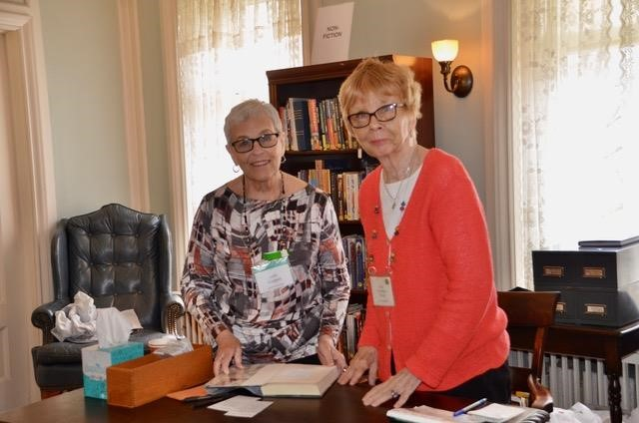

# PROFESSIONAL AND CASUAL BUSINESS CLOTHING DRIVE -

Plus Children’s Clothing October 7

Recycle your gently used casual and career clothing and accessories including ties, belts, shoes, and purses. They will be used to help build a wardrobe for someone entering or reentering the workforce or returning to school. Fall through winter clothing for men and women is appreciated. Clothing for children from infants to teen age boys and girls is also being collected due to the increased needs of families. Backpacks for students are also needed.

On Monday, October 7th, From Me To You representatives will be in front of the Gale Mansion between 8:30 and 9:30 a.m. You will be able to drive up and park briefly while volunteers help unload your donations.

If you have any questions, please call Denny Scharlemann at 612-741-2216.

# MITTEN COLLECTION

We will collect gloves, mittens, hats, underwear and socks for the children of two Minneapolis elementary schools again this year. Bring your donations on Mondays in October and November. Look for the mitten box.

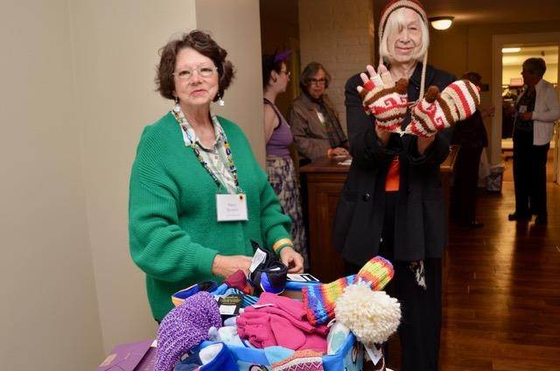

**NANCY SJOQUIST AND KAY KESSEL**

##### Share Unused Toiletries

Traveling? Free items from your dentist? Freebies from cosmetic purchases? Bring your new toiletries, dental products, and paper grocery bags with handles, and place them in the specially marked boxes in the coat room. They will be delivered to the Groveland Food Shelf.

For those with little, it means so much. Lil Lindsey

# NOMINATING COMMITTEE

Leadership Opportunities!

Each fall in accordance with the

Minneapolis Branch AAUW Bylaws, the Nominating Committee begins to seek a slate of officers for the following year. The positions to be filled for the 2025-2027 terms are the following: o Development VP o Membership VP o Marketing VP o Treasurer

o Director at Large (one-year term)

If you are interested in one of the positions listed above, please contact a member of the Nominating Committee and let them know. The list of committee members can be found in the directory.

The slate of officers will be announced at the February business meeting and voted upon at the March business meeting. The committee meets weekly in the fall until the candidates are narrowed to a final slate. Our committee welcomes suggestions for each position. You may also volunteer yourself. The responsibilities of each position are detailed in the bylaws, or you can contact one of our members. Kathleen Kohler, Chair

# COURTESY REQUESTS

To make the AAUW meeting time a good experience for ALL, please:

* Check to see that your cell phone and all other electronic devices are silent. o Reserve the two front rows in the Presidents’ Hall on the west side for those with walkers or wheelchairs.
* Reserve the last row for hostesses who need to leave early.
* Leave seats open near the aisles and in the back for those who come late. o When asking a question, stand, if you are able, and say your name.
* If you are unable to hear the speaker, please move closer to the front or raise your hand and politely tell the speaker.
* Refrain from unnecessary/lengthy comments.
* Please do not wear any fragrance. Some of our members are very allergic.
* Sit near the back of the room if you do needlework or puzzles. o At lunch, all seats are open.
* Please refrain from having conversations during the programs.

# A tree with snow fallingBAD WEATHER

CLOSING Check

your email for an announcement. Bad

weather closings will also be announced on the home screen of our website.

<https://minneapolis-mn.aauw.net/>

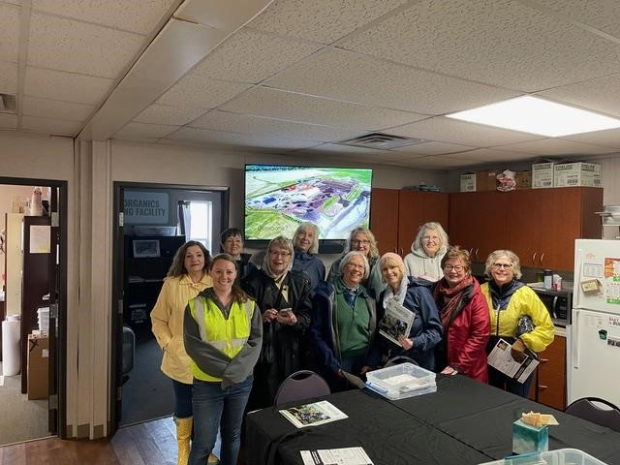

GALE MANSION FLOOR PLAN

#### Notes

**Notes**