PROGRAM PRESENTER’S PACKET 2022-2023
Thank you for agreeing to be a program presenter. We hope you will find the experience interesting and satisfying. The attached pages will help you organize the process of recruiting and supporting a speaker. By using these timelines and suggestions, you can facilitate a good experience for both your speaker and yourself.
If this is the first time you are a program presenter, you might want to contact an experienced member to mentor you in the process. We can help you find someone to fill this role if you contact us. We are also available to answer any questions you may have along the way.
Leslie Swenson
Program Vice President

Table of Contents

P.2. Checklist
p.3 Initial Contact Info and Sample Letter
p.4 Sample Confirmation Letter
p.5 Sample Information Sheet for Speaker to fill out
p.6 Tips for the day of the talk
p.7 Tech Information for Speaker
p.8 Permission to Record form for the Speaker to sign
p.9 Location and Directions
p.10 Bulletin Copy form for Presenter to fill out
p.11 Request for Honorarium
p.12 Snow Day

CHECKLIST/TIMELINE
Initial Contact with Prospective Speaker
Phone or email prospective speaker (See page 3)

If prospect agrees, send confirmation letter or email immediately(p. 4, 8)

Include the speaker form to be filled out (p.5)
Note deadline for bulletin notice, and prepare accordingly (p. 9)

One Month Prior to Program (or sooner if initial contact was a long time ago)

Contact speaker again; highlight date, location, parking (p. 9)
Determine speaker’s audio visual needs (p. 6)
Determine if speaker will be having lunch at the Gale (They get a free lunch)
Three weeks prior to program:
Submit requisition for payment of honorarium (p. 10)
Notify Susie Erickson whether or not speaker will be at lunch (612-866-5720 or serick1218@gmail.com)
Prepare your introduction
Make lunch reservations for you and your speaker:
email: aauwreservations@galemansion.com

online system: https://signup.com/login/entry/104072396041
Two weeks prior to program
Email or call Phyllis Galbraith re AV needs (phyllis.galbraith@gmail.com; 612-720-1392) (p. 6)
One week prior:
Contact speaker to confirm details; determine if he/she has time constraints

Program day: (see page 6 for detailed recommendations)
Check email/voicemail for last minute changes; bring speaker’s contact info to Gale
Check in with Guest Hostess before 9:30 and pay for your lunch
Pick up honorarium in office and membership packet at membership desk
Meet speaker at front door, hang coat in front hall closet, proceed to President’s Hall, introduce to AV person
Have speaker sign Release form (copies at podium) if not yet done (p. 8)
Remind speaker of time parameters; let him/her know that you will give 5 minute warning before Q & A and that you will move around hall with microphone for questions
Introduce speaker (Page 10 contains introduction stipulations)
Monitor Q & A time; thank speaker when ended
Present honorarium and membership packet to speaker
_____ For 9:30am presenter only – Plan to read the Recognition of Dakota Land
WRITE A THANK YOU NOTE (cards available in office)

INITIAL CONTACT WITH SPEAKER

Information to include in initial phone call/email:
- You are member of Minneapolis American Association of University Women, an organization that works to advance equity for women and girls.
- Invitation to speak to our group on (topic) on (date) at The Gale Mansion or virtually via zoom
- Lecture for 45 minutes; Q & A for 15 minutes
- Audience is generally ABOUT 150 participants, mostly women
- Offer $100 honorarium (except to elected officials or judges)
- Welcome to stay (or come early) for luncheon if meeting at the Gale
- Give your name and contact information
- You will follow up with detailed confirmation letter

SAMPLE SCRIPT for initial email/phone contact:
Hello [insert name].
My name is [insert name]. I’m contacting you on behalf of the American Association of University Women - Minneapolis (AAUW) to invite you to speak to us on Monday, _[date] at_[time] . The topic we would like you to address is [insert topic name]. We can accommodate your presentation in person or on Zoom.
AAUW is a national, inclusive, nonpartisan, secular organization dedicated to advancing equity for women and girls through advocacy, education, philanthropy and research. You may wish to visit our websites, https://minneapolis-mn.aauw.net/ or www.aauw.org, for more background about our organization.
As part of our commitment to lifelong learning, we meet each Monday to hear experts speak on a wide variety of subjects. Our [Insert committee name] has identified you as a highly knowledge speaker on the topic of [insert topic name]. We ask that you speak for about 45 minutes with an additional 15 minutes for Q&A.
The meeting location is the Gale Mansion at 2115 Stevens Avenue, Minneapolis, MN 55404, which is directly across the park from the Minneapolis Institute of Art (MIA). Usually about 150 members attend.
We provide an honorarium of $100. If your schedule permits, we invite you to join our President and others for lunch at the speaker’s table.
Please let me know by phone or email whether you can accept this invitation. I’m happy to answer any questions you may have. I look forward to hearing from you at your earliest convenience.
Sincerely,
[name]
[phone number]
[email address]

SAMPLE LETTER OR EMAIL TO CONFIRM SPEAKER
(Letterhead stationery available in office or on AAUW Website)

TO BE USED IF WE ARE MEETING AT THE GALE

*IMPORTANT TIP: If sending email, make subject line “AAUW Speaking Engagement on (date) ”

Thank you for agreeing to speak to the Minneapolis AAUW on Monday, (date) at (time), on the topic of .
We meet in the Gale Mansion, 2115 Stevens Avenue South. Again, we ask that you talk for about 45 minutes, followed by 15 minutes for Q and A. The audience will be approximately 150 members, both in the hall and on zoom.
Again, we are able to offer you an honorarium of $100. In addition, we invite you to lunch at the President’s table if your schedule permits.
We also have two other speakers that day and I invite you to stay (come) to hear them. I will let you know who they are when the information becomes available.
I must write and submit an announcement of your talk for our bulletin. I am attaching a form for you to fill out that has information I will need for our bulletin write-up. I would appreciate it if you would fill it out and return it to me as soon as you are able.
I am your contact person from AAUW. You may reach me at (include your contact information). In case of emergency, the AAUW office number is 612-870-1661.
Thank you, again, for agreeing to speak to us. We look forward to hearing your expertise and insights.
I will wait for your completed Information Form and the Release Form.

Thank you. We look forward to hearing your talk.

(Your Name)

INFORMATION FORM TO SEND TO SPEAKER AS SOON AS THEY AGREE TO SPEAK AND THEN

SAVE THE RETURNED FORM. YOU WILL NEED THIS INFORMATION

AMERICAN ASSOCIATION OF UNIVERSITY WOMEN
2115 Stevens Avenue South
MINNEAPOLIS, MN.

You are scheduled to speak AAUW on Monday-___ at ____o’clock.

In order to write up your presentation for our bulletin, please complete this questionnaire and return the information by email to me( your name) at (your email) by (put a date several weeks to be returned before your bulletin copy is due) or you could snail mail the form to me at (your address – if you are comfortable)

Your Name and title

Contact phone number (for emergencies like snow cancellation):

Your address (in case we have to mail your honorarium to you)

Biographical information such as education, career, etc. to use in our bulletin and for your introduction:

Title of Presentation:

Brief description of presentation (50-60 words max):

At a later date, when we decide how (live or zoom) you will make your presentation, I will ask if you have any tech needs.

If you have any questions, please email me or call me at

Thank you.
(Your name, Committee Name)

TIPS FOR the Day of the talk
- If you requested the honorarium for your speaker earlier, go upstairs to the AAUW office to get the check to give to your speaker.
- Pay for your lunch and check in with Susie Erickson at end of hall if your speaker is coming to lunch.
- Meet your speaker at the front door
- Have your speaker sign the Request to Record paper if they have not done so. Take the signed form up to the office. If you need a form, the tech committee has a copy for your speaker to sign.
- Have your speaker be on stage before you introduce her or him.
- Remind your speaker that their talk is for 45 minutes and that you will give them a 5 minute warning at 40 minutes.
- Remind your speaker that there will be 15 minutes of Q & A at the end and that you will carry the microphone and choose the questioner.
- Start on time.
- Request that cell phones be turned off.
For 9:30am presenter only – Plan to read the Recognition of Dakota Land
- Keep the introduction short. – 2 min max
- Give speaker the 5 minute courtesy warning.
- When the speaker’s presentation reaches 45 minutes, stand up and get the mike
- Thank the speaker and then turn to the audience and request that if they have a question that they stand If they are able, state their name and then ask their question.
- During Q and A, when you hand the mike to someone in the audience, look around to choose who will be next and, while the speaker is answering the question, give the mike to the next member.
- End on time and don’t forget to THANK THE SPEAKER
- WRITE A THANK YOU NOTE (cards available in office)

TECH INFORMATION FOR SPEAKER

SPEAKERS:

The following audio visual equipment is available for your use.
- Podium with microphone

- AAUW MacBook Pro computer with both Keynote and Microsoft Office Power Point software

- Projector for use with our Mac computer

- Lavalier microphone

- Laser pointer

- Please let us know if you will be showing a video from the internet during your presentation as it requires additional audio setup.

Speaker A/V Guidelines

1.) ALWAYS BRING PRESENTATION ON A FLASH/JUMP DRIVE ON THE DAY OF THE PROGRAM.

2.) Power Point or Keynote format is preferred.

3.) If you have a powerpoint presentation, you will have to use our computer to show the powerpoint. However, if your computer has notes that you want to use, there is room for you to set up your computer next to ours on which you can look at your notes. We also have another computer that you can use to show notes to yourself

You will be asked if you are willing to sign the Release and License Form to permit the recording of your presentation.

RELEASE FORM – PERMISSION TO RECORD AND USE

Program Title:

Date/Time:

Speaker gives permission and provides a license to AAUW Minneapolis Branch (AAUW) to record and use Speaker’s presentation (including any supplemental materials provided by Speaker) (Presentation) in the manner described below in any or all print and media forms, including but not limited to video, audio, and slides. Speaker further permits AAUW to place the Presentation in any form on a website, access to which is provided through an AAUW password protected website, for viewing by AAUW members and others invited by AAUW who visit the AAUW website. In addition, Speaker gives permission and provides a license to AAUW to take and use any image of Presenter provided by Presenter or taken in connection with the Presentation (Likeness) for use by AAUW in its promotion, publicity, advertising or electronic publication.

The Presentation or any Likeness may be electronically posted for up to two years or as determined by AAUW.

Speaker will not be compensated for the Presentation or any Likeness or the rights to use it or them other than through AAUW’s customary honorarium provided to eligible speakers. Signing this form does not guarantee that the Presentation or any Likeness will appear on the website or other location or be used in any manner by AAUW. The determination of whether the Presentation or any Likeness will be included on the AAUW website or other location and in what format is solely that of AAUW.

Speaker hereby releases AAUW from any and all claims and demands, of any kind and character, without condition or exception, arising because of its use of the Presentation or any Likeness. Speaker affirms that he/she has the permission of each and every author of any information contained in the Presentation or any Likeness, to the extent required by law for the purposes described in this Release, to use copyrighted materials within the Presentation or any Likeness.

For VALUE RECEIVED, Speaker hereby warrants that he/she has the right to execute this form, and affirms he/she is over twenty-one years of age.

Signature: Date:

Print Name:

Address:

City: State:

The tech team needs a written (email) record of the speaker’s permission or refusal to record. Please email a copy of the release form to the speaker and ask them to use the reply button with the message of whether or not we can record. That way we have an email record showing that they saw the release form and their reply.
Send the returned permission form to Esther Fabes at fabes002@umn.edu

LOCATION AND DIRECTIONS
The Gale Mansion, home of AAUW Minneapolis Branch, is located at 2115 Stevens Avenue, just one block south of Franklin and two blocks east of Nicollet. It is across from Washburn-Fair Oaks Park, two blocks north of the Minneapolis Institute of Arts. Stevens Avenue is one-way heading north between 22nd Street and Franklin Avenue. Free on-street parking is available; AAUW speakers may park in the semi-circle driveway.
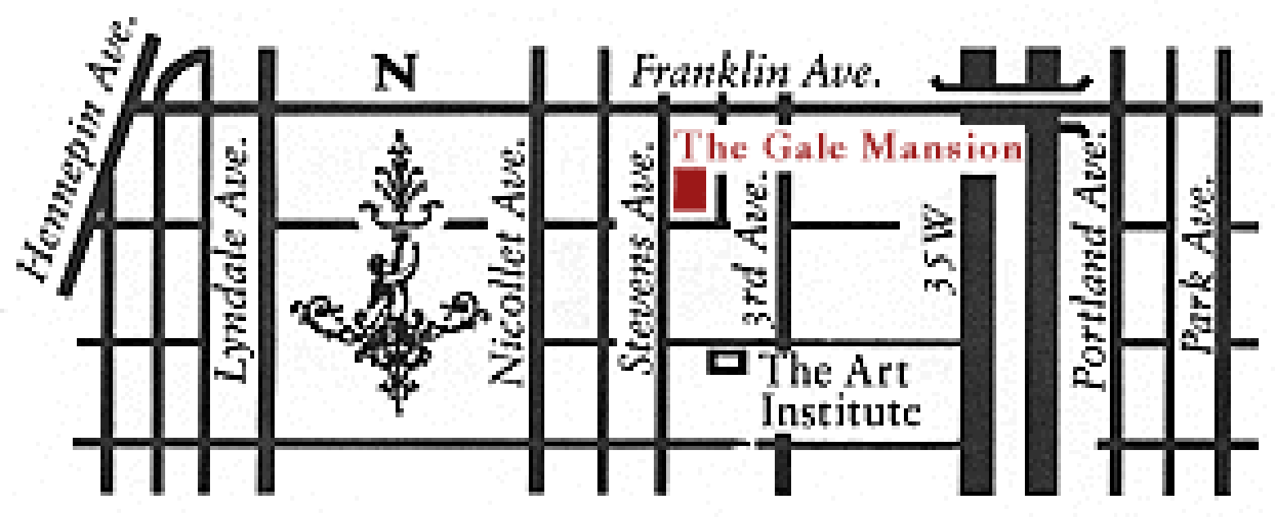

35W from the North
Follow signs for the 11th Avenue exit.
Turn left onto 11th Ave, proceed two blocks to Franklin Avenue Turn right onto Franklin Ave, proceed to 3rd Ave.
Turn left onto 3rd Ave, proceed to 22nd St,
Turn right onto 22nd St two blocks to Stevens Ave. Turn right onto Stevens.

I-94 from the North
Take the Lyndale Ave exit. Proceed south on Lyndale several blocks to Franklin Ave.
Turn left onto Franklin Ave, proceed to First Ave. Turn right onto First one block to 22nd St
Turn left onto 22nd St one block to Stevens Ave. Turn left onto Stevens.

I-94 from the East (St. Paul)
Take the 11th Street exit; proceed on 11th St to LaSalle Turn left onto LaSalle, proceed to 22nd St. (cont.) Turn left onto 22nd St to Stevens Ave.
Turn left onto Stevens.

I-394 from the West
Take the Dunwoody/Hennepin exit. Turn right on Lyndale Ave Proceed south on Lyndale several blocks to Franklin Ave.
Turn left onto Franklin Ave, proceed to First Ave. Turn right onto First one block to 22nd St
Turn left onto 22nd St one block to Stevens Ave. Turn left onto Stevens.

35W from the South
Take 31st/Lake St exit. Proceed to Lake St. Turn left and go two blocks to 1st Ave.
Turn right; proceed to 22nd St.
Turn right onto 22nd one block to Stevens Ave. Turn left onto Stevens

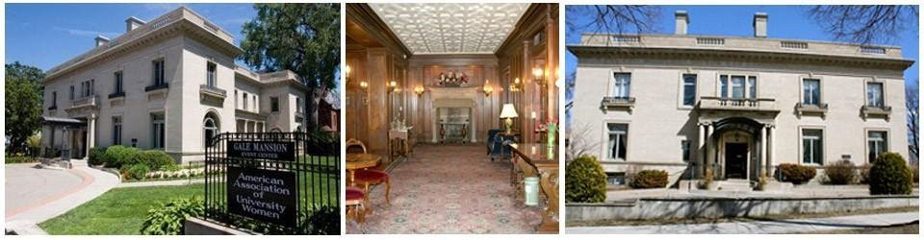

Bulletin Copy Form
Please Fill Out This Form and Return

Fill out this form. Then copy it and return to those listed below by these DEADLINE DATES
July 5, 2022 for talks in September, October, November
October 5, 2022 for talks in December, January, February
January 4, 2023 for talks in March, April, May

Day, Date, and Time:

AAUW Program Topic:

Title of this Program:

Speaker’s Name and Title

Speaker’s Email:

Speaker’s Contact #:

Speaker’s Web site (if applicable)

Speaker agreed to Zoom presentation if needed.

Program Description: Description should be approximately 50-60 words. Refer to previous bulletins for examples. Describe presentation topic. Arouse interest and curiosity!

Presenter Name:( Your Name

Phone:
E-mail:

Send copies to:
Email preferred 1) Your Topic Chair.
2) Leslie Swenson, Program VP kline012@umn.edu

KEEP A COPY FOR YOURSELF!
Requisition Form for Honorarium AAUW Minneapolis Branch

Date:

Check payable to:

For:

Amount: $

Will pick up check on:

Or mail check to speaker at:

Specific Committee:

Requested by:

Approved by Office Administrator

This form is to be filled out and presented to the office (preferably by email) for check to run three weeks prior to speaker’s engagement date.
To return this request, email to Mary Maurelli at aauwmpls@galemansion.com
If necessary, you may use standard mail, or drop off at the second floor office.

Thank you!

SNOW DAY PROCEDURE

Because we can now zoom from home, the plan is that speakers will appear on zoom instead of coming to the Gale.

1. The AAUW President will make a determination as whether or not we will meet by 8pm Sunday night

2. The President will then contact the 3 presenters (the members who engaged the speaker and are introducing the speaker) and the tech members on duty for that Monday. You will be given the names of the tech people on duty.

3. Check your email or call 612-870-1661 for a recorded message.

4. DON’T FORGET – the zoom link for your speaker. Copy the link from the Thursday zoom link email. The link is just the date. Paste it into an email to your speaker and hope for the best!

4. The 3 presenters will then each:
a. contact their respective speaker and let them know of the change.
Ask if they can zoom from home.
b. Tell the speaker you will email the zoom link to them and then do it immediately.
c. If they have any tech questions, they can contact one of the tech persons. Check with Alice Heth or Nan Beman to find out who the tech people on duty are
d. Ask the speaker to log onto zoom 15 minutes before they are scheduled to speak so we can make sure all the technology is working correctly.

