PROGRAM PRESENTER’S PACKET

Thank you for agreeing to be a program presenter. We hope you will find the experience interesting and satisfying. The attached pages will help you organize the process of recruiting and supporting a speaker. By using these timelines and suggestions, you can facilitate a good experience for both your speaker and yourself.
If this is the first time you are a program presenter, you might want to contact an experienced member to mentor you in the process. We can help you find someone to fill this role if you contact us. We are also available to answer any questions you may have along the way.
Susie Erickson Doris Grimes
Program Vice Presidents

Page 2
Timeline and Checklist

Initial Contact with Prospective Speaker
Phone or email prospective speaker (See page 3)

If prospect agrees, send confirmation letter or email immediately (p. 4, 8)
Note deadline for bulletin notice, and prepare accordingly (p. 5)

One Month Prior to Program (or sooner if initial contact was a long time ago)

Contact speaker again; highlight date, location, parking (p. 9)
Determine speaker’s audio visual needs (p. 6)
Determine if speaker will be having lunch at President’s Table

Three weeks prior to program:
Submit requisition for payment of honorarium (p. 7)
Notify Susie Erickson whether or not speaker will be at lunch (612-866-5720 or serick1218@gmail.com)

Prepare your introduction (p. 10)

Two weeks prior to program
Email or call Phyllis Galbraith re AV needs (phyllis.galbraith@gmail.com; 612-720-1392) (p. 6)

Make lunch reservations for you and your speaker: (651-220-4777)

One week prior to program:
Contact speaker to confirm details; determine if he/she has time constraints

Program day: (see page 10 for detailed recommendations)
Check email/voicemail for last minute changes; bring speaker’s contact info to Gale
Check in with Guest Hostess before 9:30 and pay for your lunch
Pick up honorarium in office and membership packet at membership desk
Meet speaker at front door, hang coat in front hall closet, proceed to President’s Hall, introduce to AV person
Have speaker sign Release form (copies at podium) if not yet done (p. 8)
Remind speaker of time parameters; let him/her know that you will give 5 minute warning before Q & A and that you will move around hall with microphone for questions
Introduce speaker (Page 10 contains introduction stipulations)
Monitor Q & A time; thank speaker when ended
Present honorarium and membership packet to speaker
WRITE A THANK YOU NOTE (cards available in office)

INITIAL CONTACT WITH SPEAKER Page 3

Material to include in initial phone call:
- You are member of Minneapolis American Association of University Women, an organization that works to advance equity for women and girls.
- Invitation to speak to our group on (topic) on (date) at Gale Mansion
- Lecture for 45 minutes; Q & A for 15 minutes
- Audience is generally 150-225, mostly women
- Offer $100 honorarium (except to elected officials or judges)
- Welcome to stay (or come early) for luncheon
- Ask for preferred contact information and curriculum vitae or biographical info
- Give your name and contact information
- You will follow up with detailed confirmation letter

Sample script for initial contact:
“Hello. My name is , and I am a member of the Minneapolis American Association of University Women, an organization that works to advance equity for women and girls. I am calling to invite you to speak to our group on the topic of on Monday,
(date) at o’clock at the Gale Mansion, our branch headquarters in Minneapolis. We are able to offer an honorarium of $100 and also invite you to join our President and others for lunch. Our audience size is generally 150-225, mostly women. We would ask that your lecture be approximately 45 minutes, followed by a 15-minute Q&A. [If appropriate: In addition you would be welcome to sell copies of your book/s after the meeting]
(If accepts) I will be sending you a confirmation letter that outlines all pertinent details. Do you prefer correspondence by email or regular mail? In the interim, would you please email me your
curriculum vitae or biographical information at . Should you have any
further questions, you may call me at . Thank you for agreeing to speak to us.

Record the following information for further use and bulletin notice:

Program Title: Topic Committee: _

Speaker’s Name: __ Affiliation:_

Speaker’s address

Speaker’s phone numbers: (H) _ (C) _ Speaker’s email
Program Date _ _ Time

Page 4

SAMPLE LETTER OR EMAIL TO CONFIRM SPEAKER
(Letterhead stationery available in office or on AAUW Website)

*IMPORTANT TIP: If sending email, make subject line “AAUW Commitment on ”

Thank you for your commitment to speak to the Minneapolis AAUW on (date) at (time), on the topic of . The AAUW is a national, inclusive, non-partisan, non- sectarian organization that works to advance equity for women and girls through advocacy, education, philanthropy and research. Our members appreciate speakers who present well- balanced information and positions. You may wish to visit our websites, www.minneapolis- mn.aauw.net or www.aauw.org, for more background about our organization.
You will give your talk in our Presidents’ Hall at the Gale Mansion, 2115 Stevens Avenue South (directions enclosed). You may park at the front of the curved driveway at the main entrance, where I will meet you 15 minutes prior to your talk. We ask that your lecture be 45 minutes, followed by 15 minutes for Q and A. The audience will be approximately 150-225, mostly women.
We are able to offer you an honorarium of $100. In addition, we invite you to lunch at the President’s table if your schedule permits. Please let me know if you will join us for lunch so I can make a reservation.
I must write and submit an announcement of your talk for our bulletin. Therefore, I would appreciate receiving a suggested title and brief description of the lecture by (date), as well as the biographical information you would like me to use when I introduce you to the audience. In addition, please let me know of your audio-visual needs for the talk. I enclose a list of the equipment available for you. You may send all the above information to me via email.
We would like to record your lecture for our members who may miss the meeting. I am enclosing a Release Form if you agree to that recording. You may bring the Release Form with you, but I will also have a form for you on the day of your talk.
I am your contact person from AAUW. You may reach me at (include your contact information). In case of emergency, the AAUW office number is 612-870-1661.
Thank you, again, for agreeing to speak to us. We look forward to hearing your expertise and insights.

Page 5
Bulletin Copy Form

The Bulletin will be printed three times during the 2019-2020 year. Deadlines for submitting copy are:

July 3, 2019 (September, October, November)
October 2, 2019 (December, January, February) January 8, 2020 (March, April, May, June, July, August)

Day, Date, and Time:

AAUW Program Topic:

Title of this Program:

Speaker’s Name:

Speaker’s Title or Position:

Speaker’s Email:

Speaker’s Contact #:

Speaker’s Web site:

Program Description: Description should be approximately 50-60 words. Refer to previous bulletins for examples. Describe presentation topic. Arouse interest and curiosity!

Your Name:

Phone:
E-mail:

Send copies to:
Email preferred 1) Your Topic Chair.

Susie Erickson, Program VP serick1218@gmail.com
- Doris Grimes, Program VP DLW5400@aol.com

Keep a copy for yourself!

Revised April 2019

AUDIO VISUAL PRESENTATION AT AAUW MINNEAPOLIS

SPEAKERS:

The following audio visual equipment is available for your use.
- Podium with microphone

- Projector for use with computer

- Lavalier microphone

- Laser pointer

- Remote mouse

- Sound cord hook-up for showing video from internet

- AAUW MacBook Pro computer with both Keynote and Microsoft Office Power Point software

Speaker A/V Guidelines

1.) ALWAYS BRING PRESENTATION ON A FLASH/JUMP DRIVE ON THE DAY OF THE PROGRAM.

2.) Power Point or Keynote format is preferred.

3.) You may email your presentation to the AAUW computer in advance at: mpls.aauw@gmail.com. In the subject line include your name, date and time of presentation. Also, bring the presentation on flash/jump drive as backup.

4.) If you feel more comfortable using your own computer, you may.
You will be asked if you are willing to sign the Release and License Form to permit the recording of your presentation.

PRESENTER:

Prior to your speaker’s program, email Phyllis Galbraith at phyllis.galbraith@gmail.com the speaker’s audio visual needs. This information will be relayed to the scheduled a/v tech members in charge for the week. Questions: Call Phyllis at 612-720-1392 or send email to phyllis.galbraith@gmail.com

Page 7
Requisition Form for Honorarium AAUW Minneapolis Branch

Date:

Check payable to:

For:

Amount: $

Will pick up check on:

Specific Committee:

Requested by:

Approved by:

Must have approval signature by your committee chair before payment can be issued.

This form is to be filled out and presented to the office for check to run three weeks prior to speaker’s engagement date. To return this request, please use standard mail, email (type requested and approval names) or drop off at the second floor office.

Thank you!

RELEASE FORM – PERMISSION TO RECORD AND USE
Page 8

Program Title:

Date/Time:

Speaker gives permission and provides a license to AAUW Minneapolis Branch (AAUW) to record and use Speaker’s presentation (including any supplemental materials provided by Speaker) (Presentation) in the manner described below in any or all print and media forms, including but not limited to video, audio, and slides. Speaker further permits AAUW to place the Presentation in any form on a website, access to which is provided through an AAUW password protected website, for viewing by AAUW members and others invited by AAUW who visit the AAUW website. In addition, Speaker gives permission and provides a license to AAUW to take and use any image of Presenter provided by Presenter or taken in connection with the Presentation (Likeness) for use by AAUW in its promotion, publicity, advertising or electronic publication.

The Presentation or any Likeness may be electronically posted for up to two years or as determined by AAUW.

Speaker will not be compensated for the Presentation or any Likeness or the rights to use it or them other than through AAUW’s customary honorarium provided to eligible speakers. Signing this form does not guarantee that the Presentation or any Likeness will appear on the website or other location or be used in any manner by AAUW. The determination of whether the Presentation or any Likeness will be included on the AAUW website or other location and in what format is solely that of AAUW.

Speaker hereby releases AAUW from any and all claims and demands, of any kind and character, without condition or exception, arising because of its use of the Presentation or any Likeness. Speaker affirms that he/she has the permission of each and every author of any information contained in the Presentation or any Likeness, to the extent required by law for the purposes described in this Release, to use copyrighted materials within the Presentation or any Likeness.

For VALUE RECEIVED, Speaker hereby warrants that he/she has the right to execute this form, and affirms he/she is over twenty-one years of age.

Signature: Date:

Print Name:

Address:

City: State:

Page 9
LOCATION AND DIRECTIONS
The Gale Mansion, home of AAUW Minneapolis Branch, is located at 2115 Stevens Avenue, just one block south of Franklin and two blocks east of Nicollet. It is across from Washburn-Fair Oaks Park, two blocks north of the Minneapolis Institute of Arts. Stevens Avenue is one-way heading north between 22nd Street and Franklin Avenue. Free on-street parking is available; AAUW speakers may park in the semi-circle driveway.
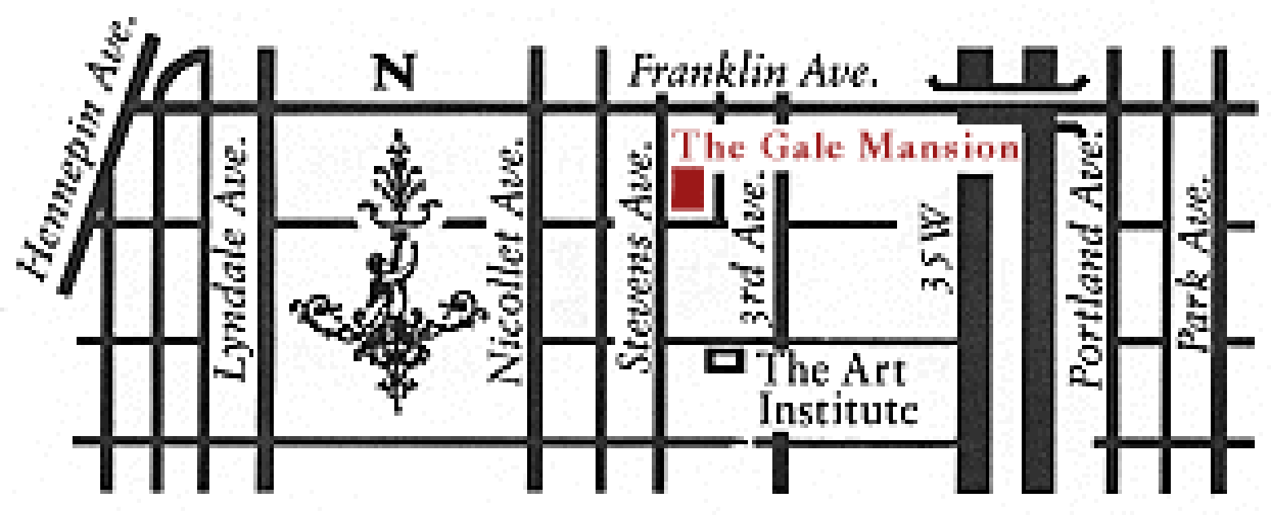

35W from the North
Follow signs for the 11th Avenue exit.
Turn left onto 11th Ave, proceed two blocks to Franklin Avenue Turn right onto Franklin Ave, proceed to 3rd Ave.
Turn left onto 3rd Ave, proceed to 22nd St,
Turn right onto 22nd St two blocks to Stevens Ave. Turn right onto Stevens.

I-94 from the North
Take the Lyndale Ave exit. Proceed south on Lyndale several blocks to Franklin Ave.
Turn left onto Franklin Ave, proceed to First Ave. Turn right onto First one block to 22nd St
Turn left onto 22nd St one block to Stevens Ave. Turn left onto Stevens.

I-94 from the East (St. Paul)
Take the 11th Street exit; proceed on 11th St to LaSalle Turn left onto LaSalle, proceed to 22nd St. (cont.) Turn left onto 22nd St to Stevens Ave.
Turn left onto Stevens.

I-394 from the West
Take the Dunwoody/Hennepin exit. Turn right on Lyndale Ave Proceed south on Lyndale several blocks to Franklin Ave.
Turn left onto Franklin Ave, proceed to First Ave. Turn right onto First one block to 22nd St
Turn left onto 22nd St one block to Stevens Ave. Turn left onto Stevens.

35W from the South
Take 31st/Lake St exit. Proceed to Lake St. Turn left and go two blocks to 1st Ave.
Turn right; proceed to 22nd St.
Turn right onto 22nd one block to Stevens Ave. Turn left onto Stevens

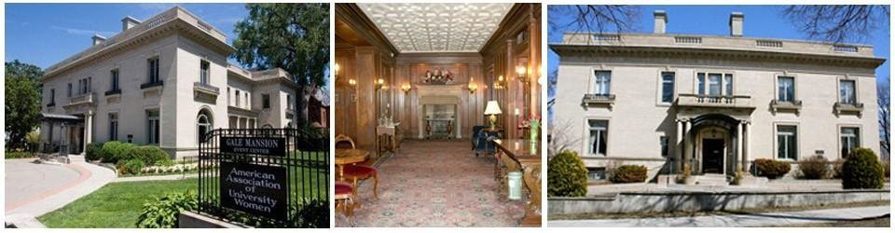

Before lecture:

PROGRAM DAY RECOMMENDATIONS
Page 10

- Be at door early to meet your speaker; coat can be hung in front stair closet. Proceed to Hall, assist in setting up AV with tech person; invite speaker to sit on stage on chair provided.
- Remind speaker of time parameters again. Let speaker know you will hold up 5-minute sign and will carry microphone for questions.

- Start on time, even if it means talking over hubbub.

Introduction:

- First sentence: “Please turn off or silence your cell phones.”

- Give your introduction, which you have prepared and practiced ahead of time. It should be informative, welcoming, BUT BRIEF – 2 minutes or less. A good rule of thumb is one page, double spaced, size 14 font. Be sure to present a clear statement of the topic and a concise description of significant, pertinent and interesting parts of the speakers’ background and education.
- Last sentence: “Please welcome Mr./Ms./Dr. ” During lecture:
- Monitor time

- Hold up “5 minute” sign after 40 minutes

- If speaker goes beyond allotted time, stand and hold the microphone as a cue to speaker to finish

Question and Answer Session:

- Portable microphone is near edge of stage. (You might try it out prior to program to make sure you know how it works.)

- After lecture, turn mike on. Model the proper position for speaking into the microphone: HORIZONTALLY, 90 DEGREES FROM YOUR MOUTH, NOT UNDER YOUR CHIN

- Ask questioner to stand, if able, speak directly into the mike, and ask ONE QUESTION so we can hear as many as possible.

- Look around and anticipate who will ask the next question, and move to her/him as quickly as possible.

- Monitor the time and announce the last question.

- Graciously thank the speaker.

- Before announcements, escort speaker to President’s table or to coat closet.

- As soon as possible, write thank you note.

